**Academic-**

This module is used to describe things that relate to the work for the students such as, their academic Syllabus, schedule of their Online classes, Timetable, Notes, Assignment, Student Attendance, Co-curricular activities.

This module consists of 10 sub modules which are as follows: -

1. **My Syllabus**

In this module you can search your syllabus of any subjects of your semester. You will also find your existing syllabus there in the module.

Picture show the syllabus of Academic front screen-

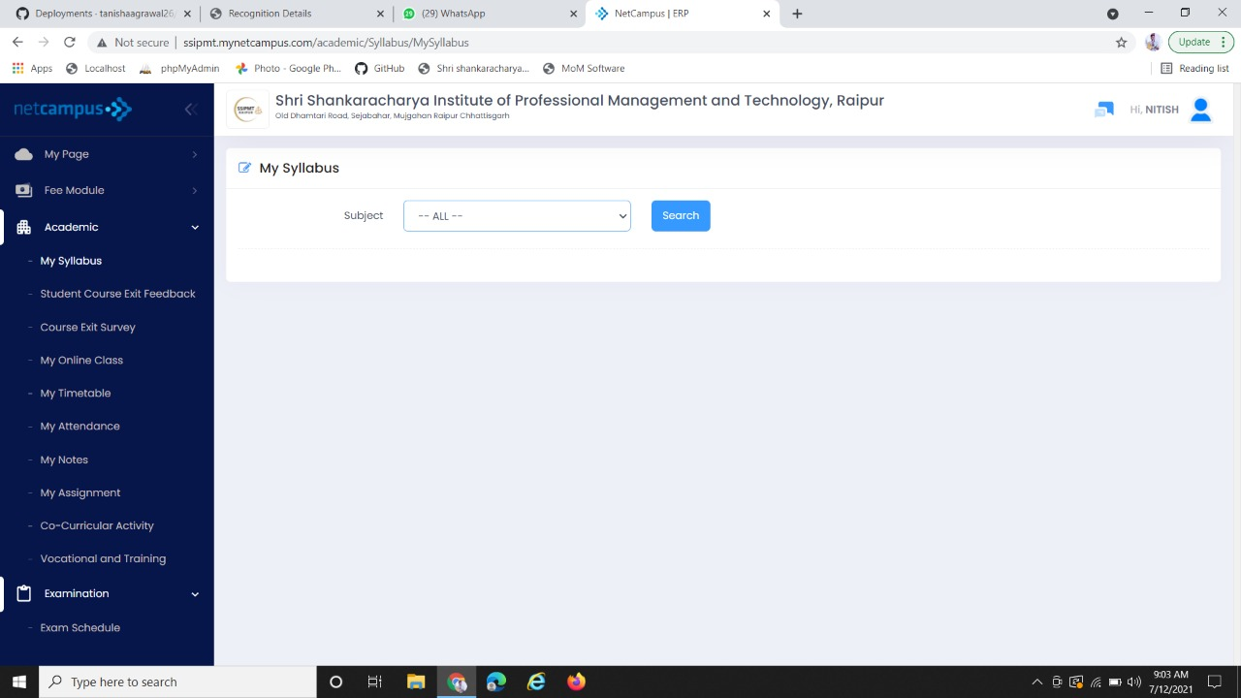

Here, you can search syllabus of any subjects

After clicking on search button, you will get the syllabus

1. **Student Course Exit Feedback**

In this module student can give their feedback about their departments, teacher’s, their library facilities, sport facilities etc. after their course completion.

If students want to give any other suggestion, they can give in the Suggestion box there. After filling Feedback form student have to click on submit button.

Below picture shows the look of a Feedback form-

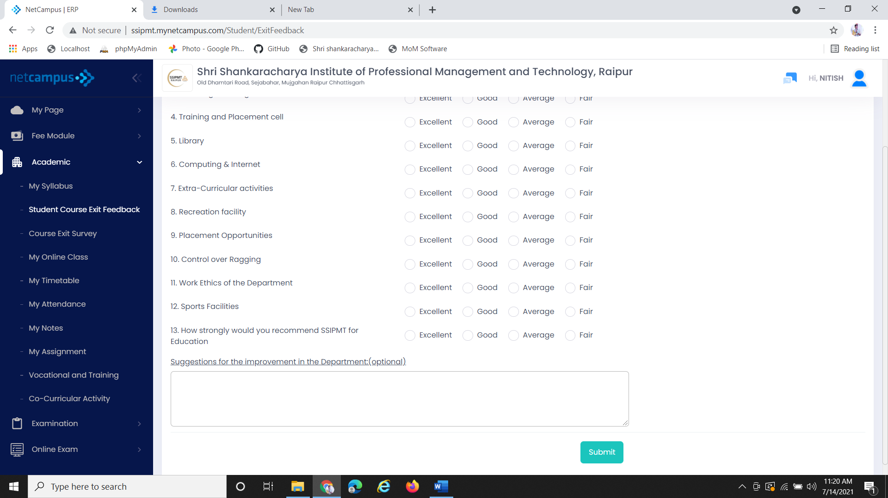

After filling feedback click on submit

Student can give any suggestion here in this box

On the basis of given parameter student can give their feedback by clicking any one option

1. **Course Exit Survey**

Course exit survey is typically an activity of evaluating phase. This is a course feedback survey. Student have to answer questions below so Institution can try to improve the course in future semester.

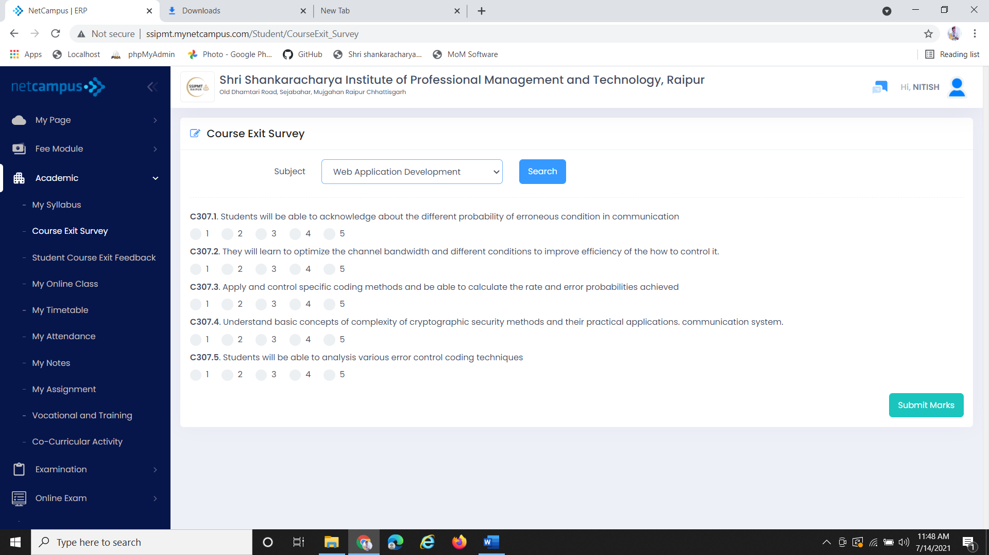

You can search any subject from your course

Student have to rate out of 5 as per the question asked.

as

After filling survey form click on submit Marks.

After selecting subject click on search Button

1. **My Online Class**

My online class sub module will update you with your online lectures. After click on My Online Class you will get online tutorial room. In that you have to set date (which day you’re checking) and your faculty name. After putting the data click on search button you will get the scheduled lectures with Date, Timing and topic of the lecture.

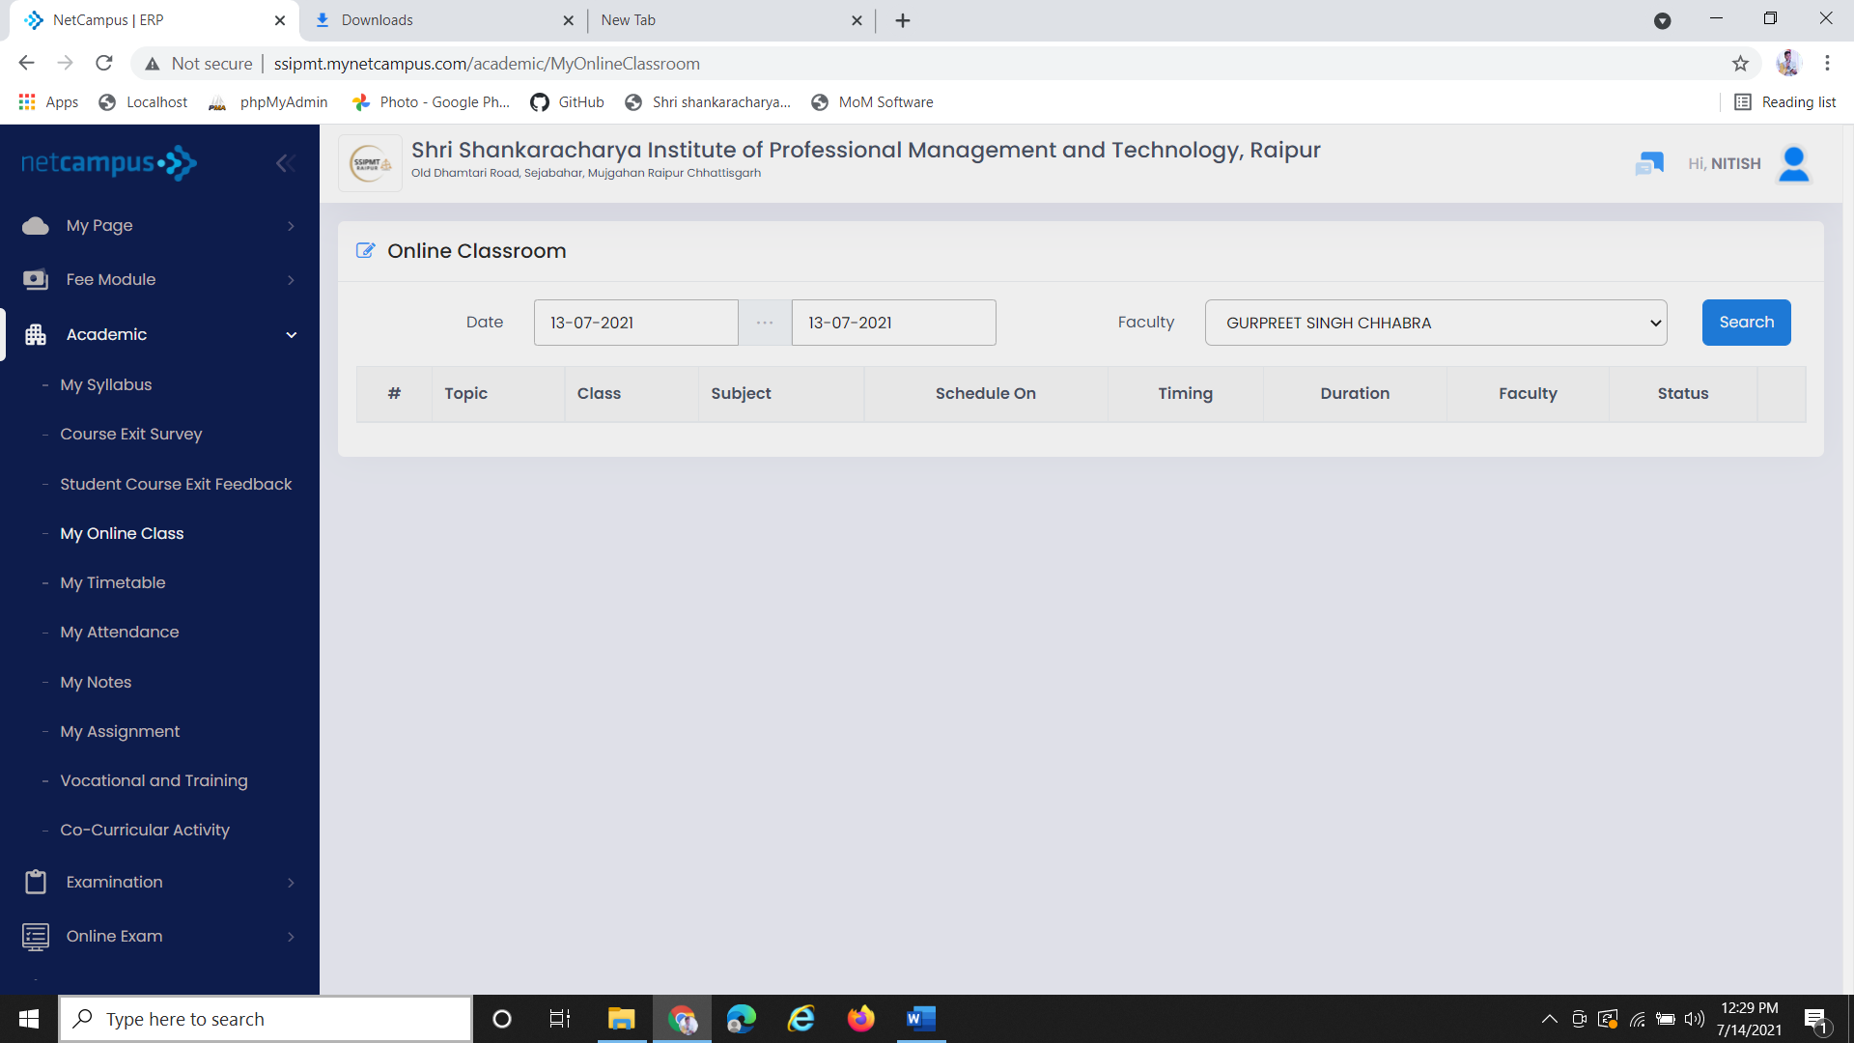

Set the date which ever day you want to check your lectures

After clicking search you will get the topic, subject, class, timing of the particular lectures

After entering the date and faculty name click on search Button

Here, Put your Faculty Name

1. **My Timetable**

In this module My Timetable, will schedule the designating time at which the lecture held for the week. Student can click on “Go live” for joining the online lectures at the given time.

Below the picture shows the front screen of My Timetable -

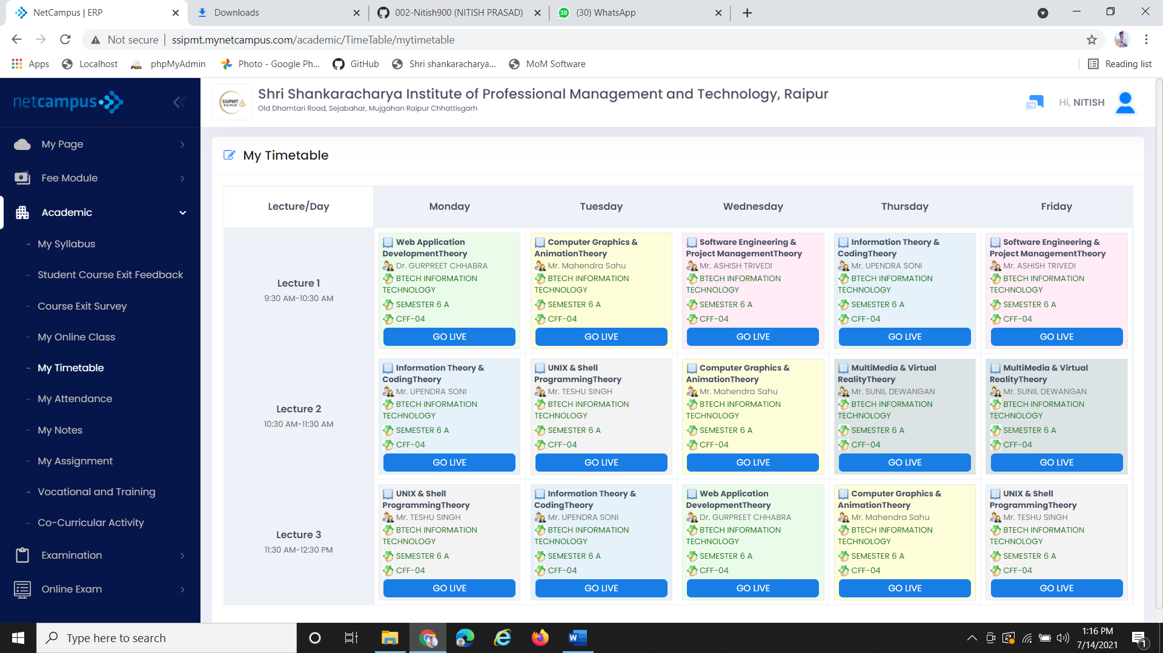

After clicking on Go Live you can join the session at given particular time

1. **My Attendance**

My Attendance module will give the record of attendance of month or a semester of students. It will give the complete data of Attendance of each and every Subject separately out of total lecture.

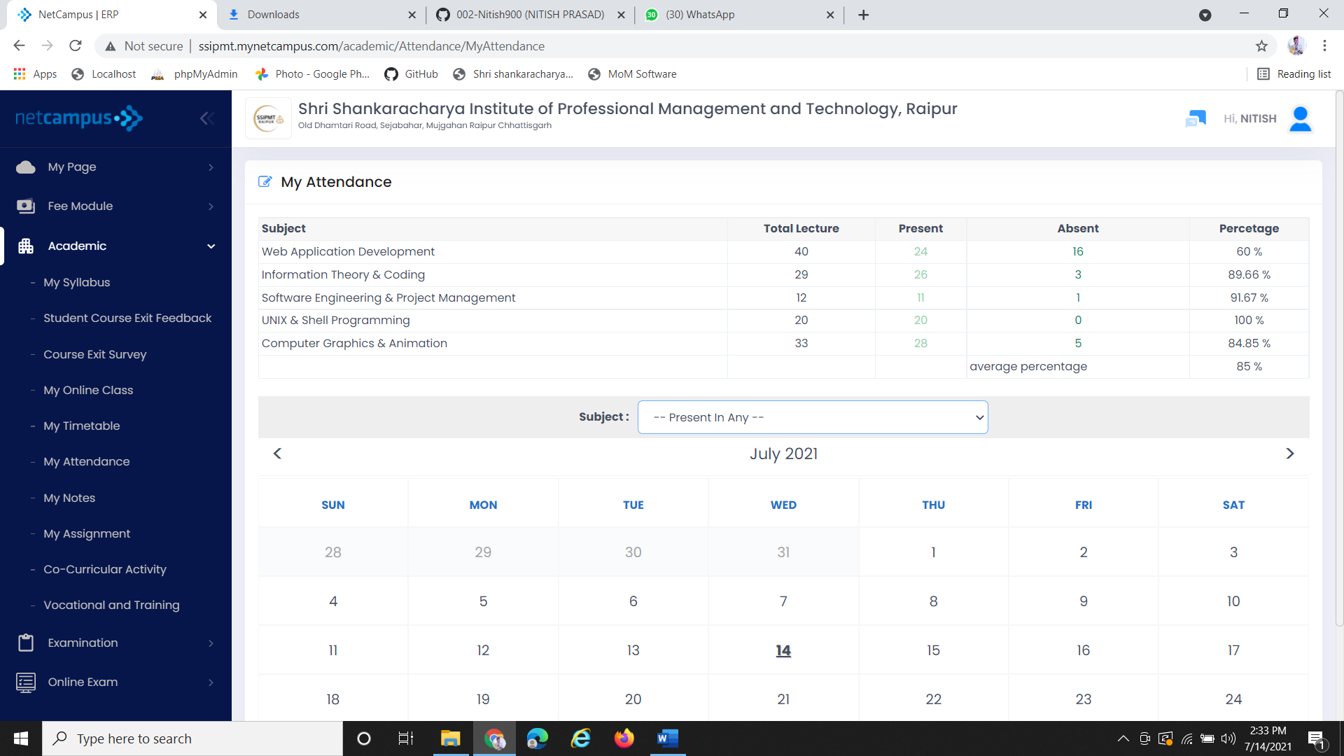

Average percentage of a semester

Student present &Absent out of total lectures

Total lectures taken by Faculty

1. **My Notes**

In this module student can access their notes of whichever subject they want. After lectures teachers will upload notes of particular subject. Student can download the notes from there.

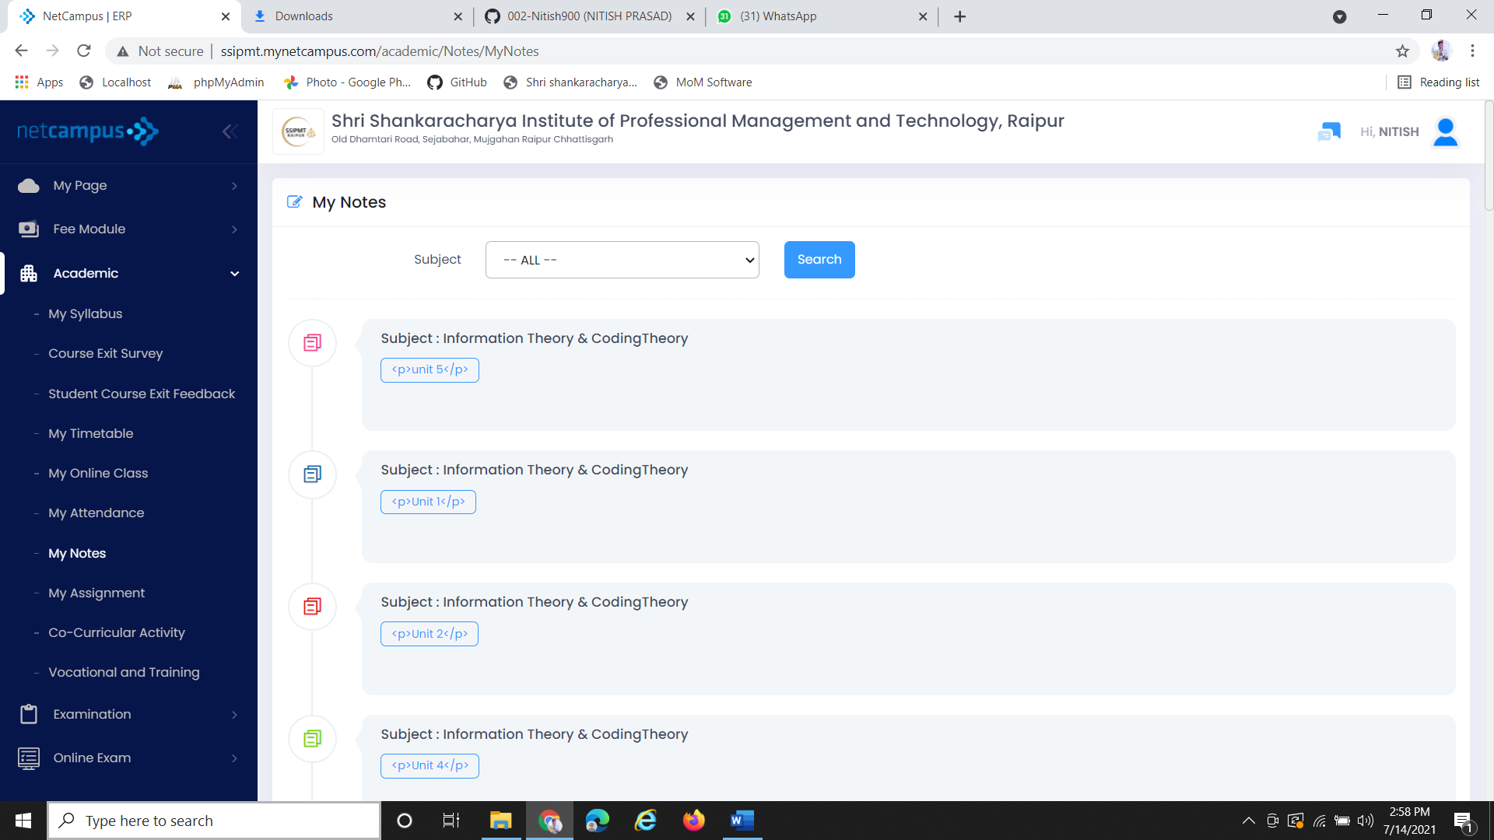

Click on search button for Results

You can choose the subject from here

Notes of particular subject uploaded by subject teacher

1. **My Assignment-**

In this module student can check their assignments if they have any task to complete. Student can also submit their assignments from here on given date. The student get the detail of assignment after clicking on subject of the assignment they get to do.

Picture below show how this module works-

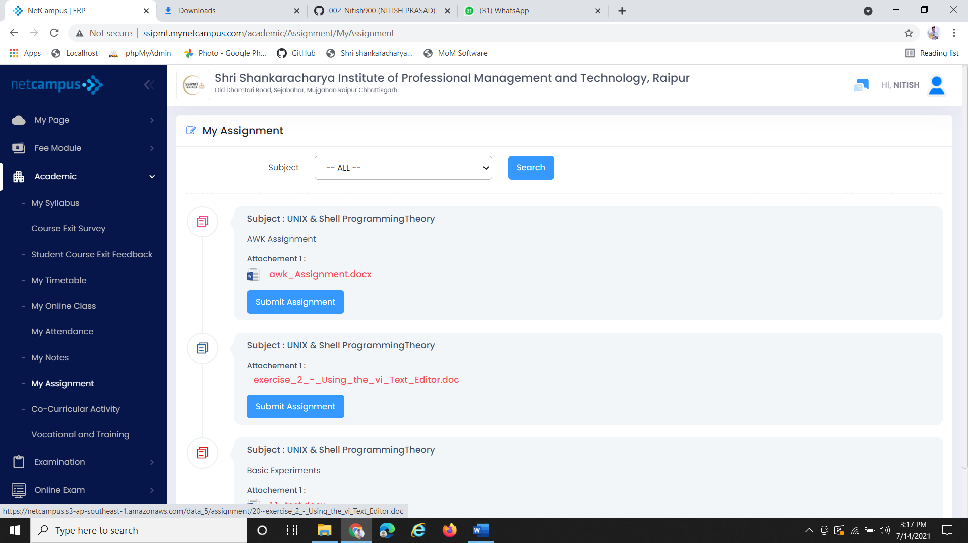

For submitting assignments click on” Submit Assignment” Button

After clicking search button you will get the Assignments

From this you can check the subjects if you have any pending assignments

After Clicking on “Submit Assignment” Button the new page will open with the details of that particular Assignments.

The picture below shows the page front View of Assignment submission.

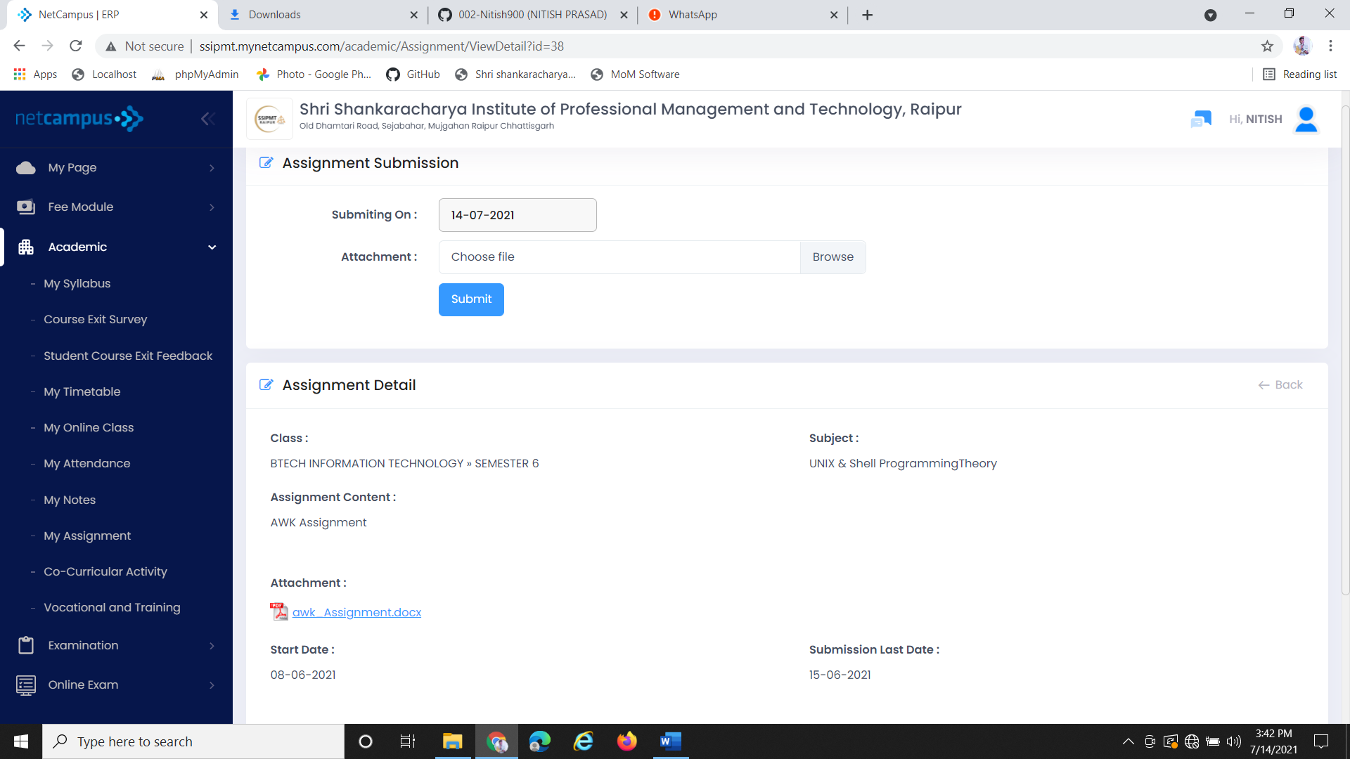

Detail of next Assignment for completion before last date.

After choosing or Browsing the file click on Submit Button

It will set the date automatically the date student is submitting his/her assignment

1. **Co-Curricular Activity**

In co-curricular activity student can add up their Certificate in which ever events they take part apart from academics like sports, Music, Dance, Coding etc. Student can add more than one certificates in this module by clicking “Add New” which is on the right side of the screen.

Students can also search the upcoming events from this.

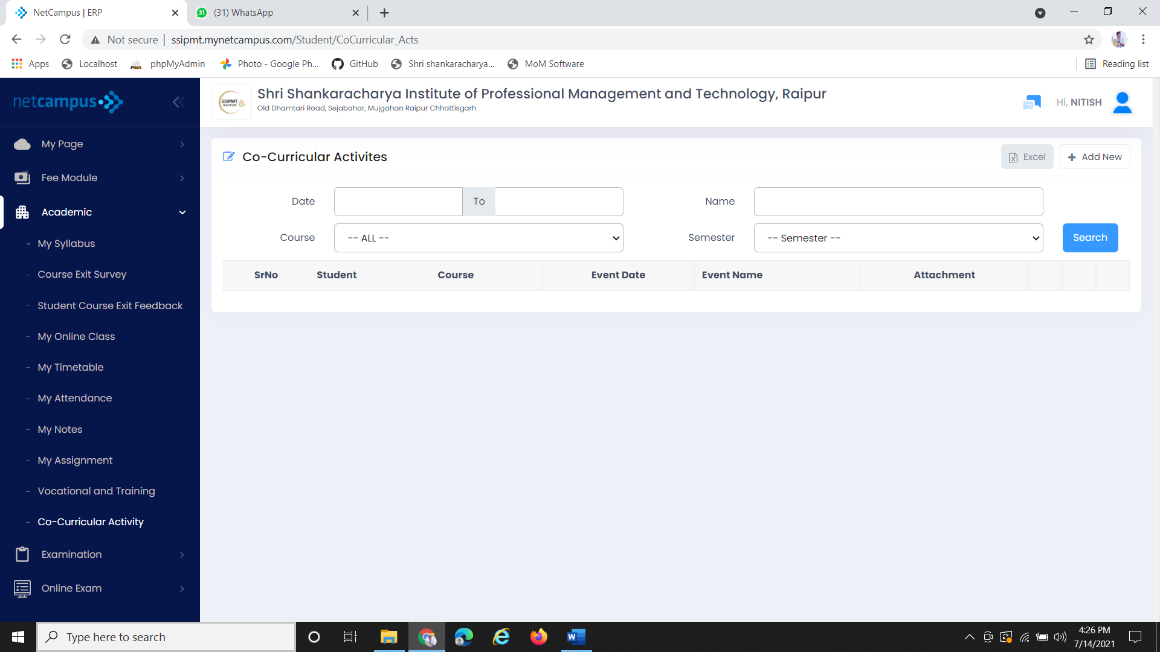

You can add your detail in excel sheet too

You can add new details on clicking this button

After filling the above details click on search button

Choose your course

On clicking “Add New” Button you will get this page for entering details of your certification and you will add your detail in Excel sheet too.

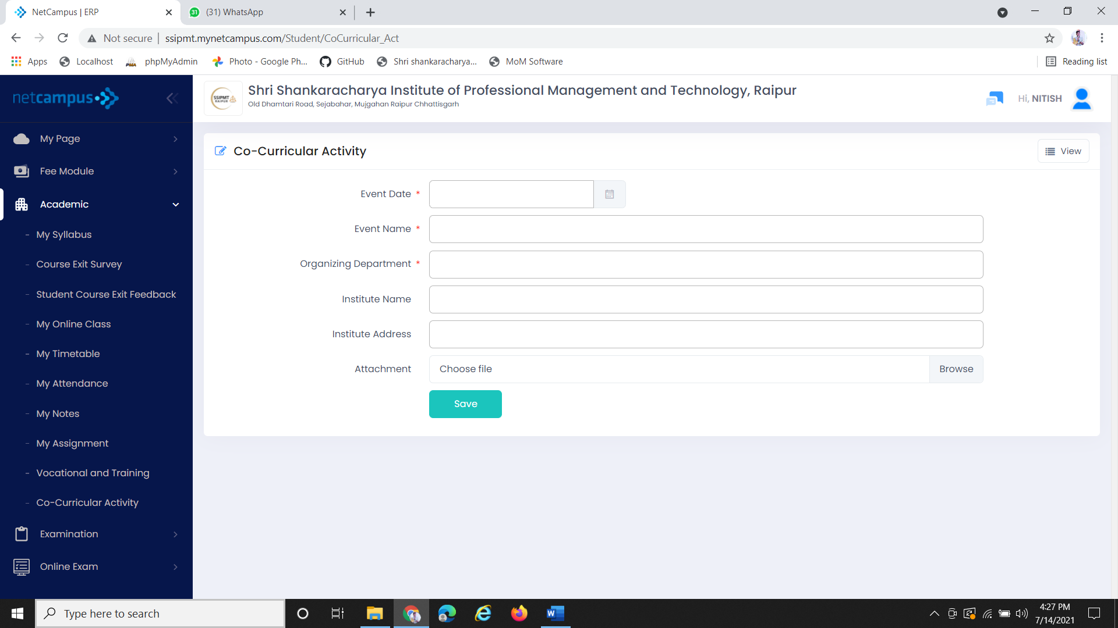

You can view from here whatever you have save

After filling the detail click on save Button. It’ll automatically save to the excel sheet

Fill the above details like Event name, date, Institution and attachment of Certificate

1. **Vocational and Training**

In Vocational and Training, student can check if there is any training or not from the department. If student already did some training, they can add their Training certificate here with the details of that training like organization name, Date of ending and joining, vocational type and etc.

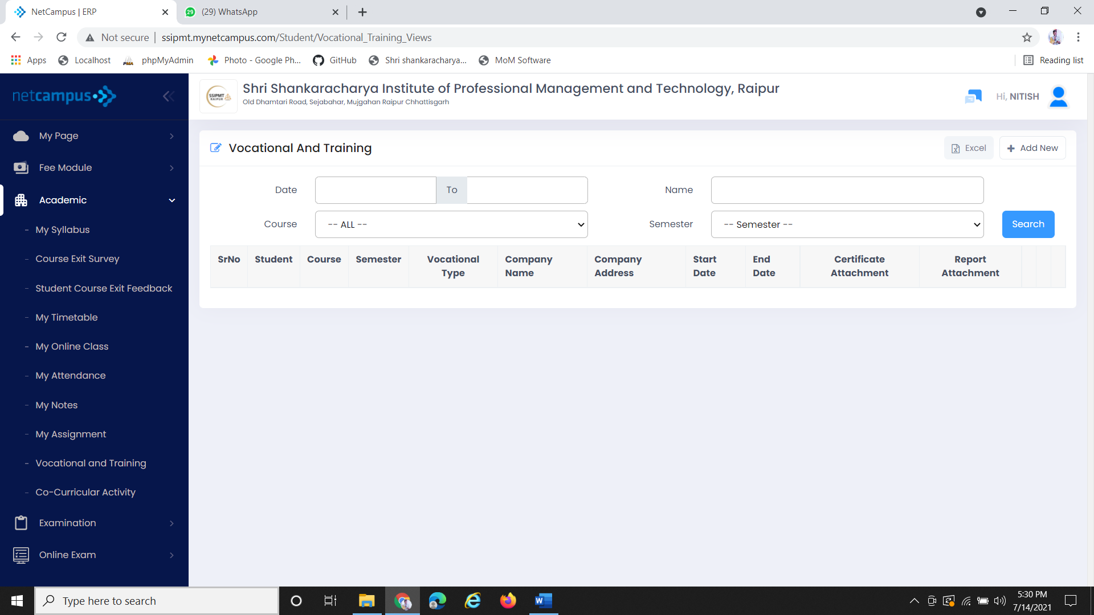

You can add your trainings you did

After filling the details, click on search button if there’s any training from department it will display below the details of trainings

Fill the details above details

**Examination-**

This module is used to describe schedule of exam and student exam result they can see the timetable of their Class Test, main exam and can view their class test result too.

This module is consisting of two sub modules i.e.

1.**Exam Schedule**

In Exam schedule student can see their exam dates when the Class test and main exam will schedule. Different

Semesters have different timetables. Student can see the timetable of different academic years.

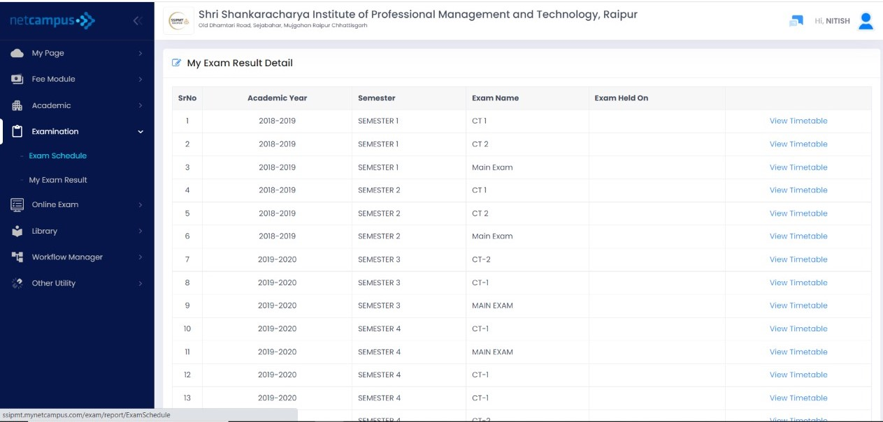

Click on this to get the timetable

Which Timetable you want to see CT1, CT2, Main exam

Which semester you want to check

You can select which academic year you want to see Timetable

2**. My Exam Result**

My Exam Result will show the score of your class Test 1 & class Test 2 which student get in different subject of their semesters with calculation of average percentage of different CT’S.

The front screen of My exam result is given below:

On clicking My Exam Result you will get to see the result of your Class Test.

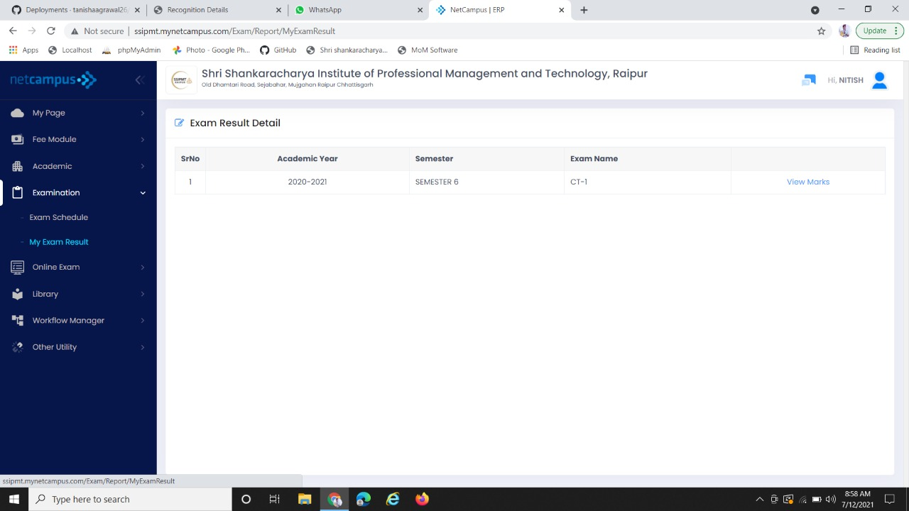

For viewing marks click on “view Marks” you will get what you score in CT-1

It’s showing the semester and exam name. For ex. It’s showing the result of semester 6 CT -1